SUBJECT-ENGLISH
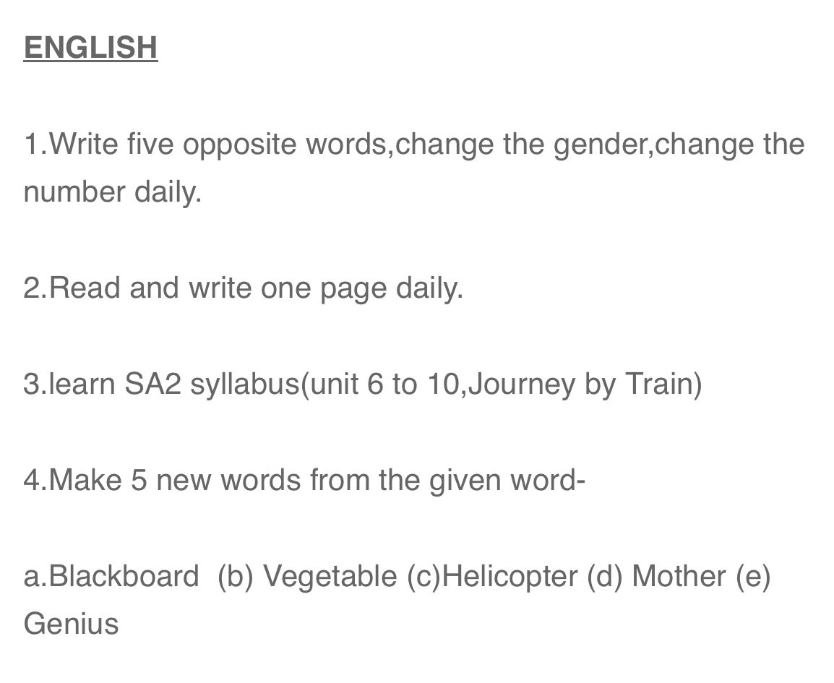

SUBJECT-MATHS
Q1. Learn and write table from 2 to 15.
Q2. 10 questions of smart chart.
Q3. 30 sums of addition and subtraction. ( l and ml)
Q4. 30 sums of multiplication and division.

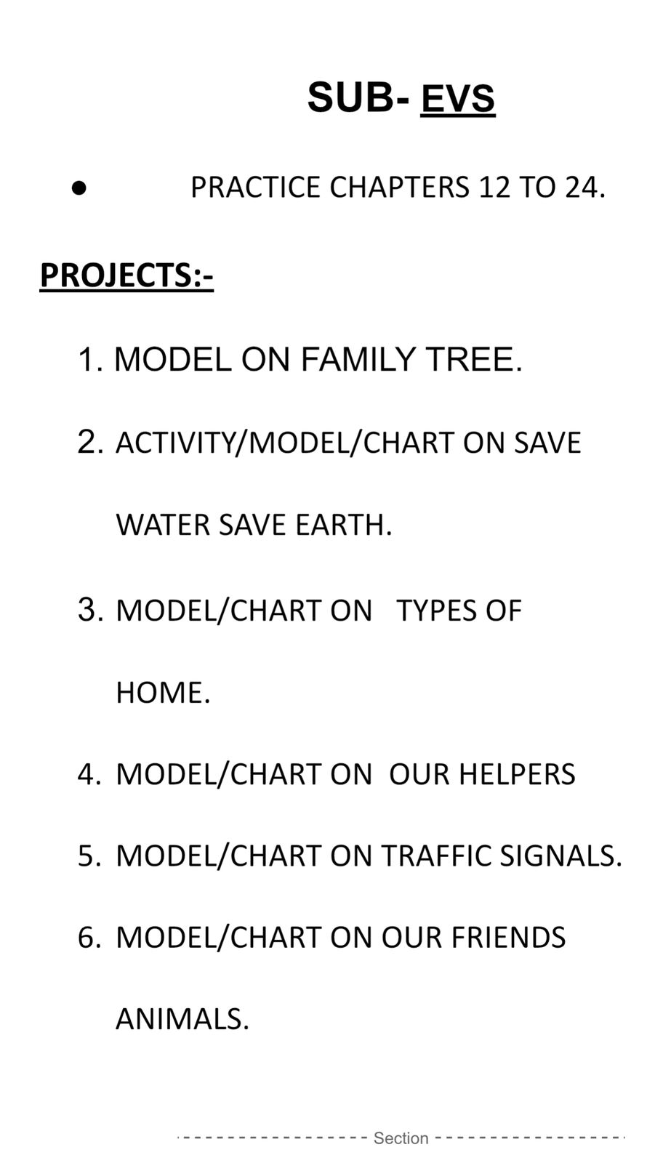

SUBJECT-LIBRARY
