पीएम श्री केंद्रीय विद्यालय जोशीमठ
शीतकालीन गृह कार्य
कक्षा 4
विषय:- हिन्दी
1.एक पेज सुलेख लिखना |
2.10 विलोम शब्द लिखना |
3.एक अवकाश के लिए प्रार्थना पत्र लिखना | (विषय-शादी मे जाने के लिए)
4.महात्मा गाांधी के बारे मे 10वाक्य लिखना |
5.पाठ 8 से 14 तक की पुनरावृति करना करना| (only reading)

SUBJECT-ENGLISH
Q1. Write 30 sentences using helping verb. Eg- is, am, are, was, were etc.
Q2. Learn all the work done in your notebook.
Q3. Write 5 actions that would make other happy and 5 actions that would make others unhappy.
Q4. Read English newspaper/text book daily and identify the difficult word and try to know their meaning from the dictionary (at least 25).
Q5. Write 10 lines on your favourite sports person

SUBJECT-ART
Make a 5 Clay craft like Caterpillar, owl, Bug Garden Stakes, medals, sea creatures, mini cupcakes, Bee and flower tic tac toe game, clay fish and many more.
For Examples.
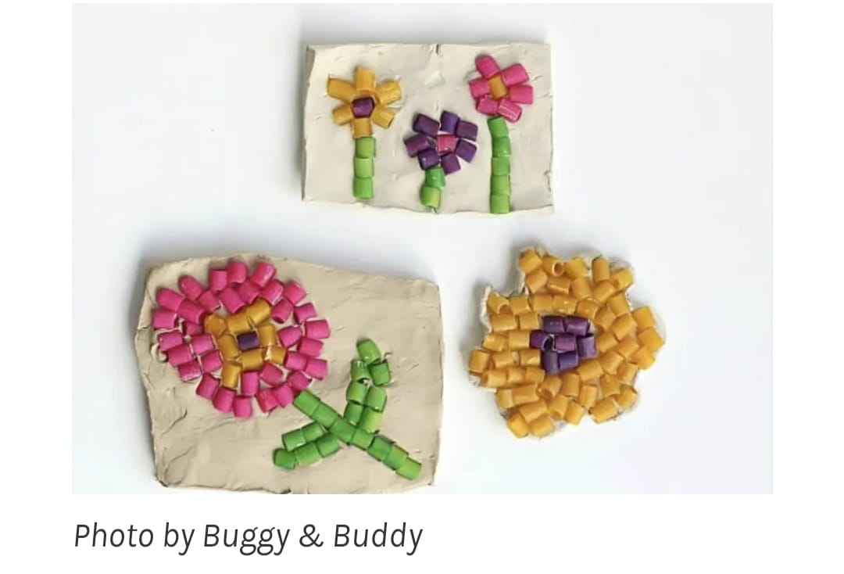

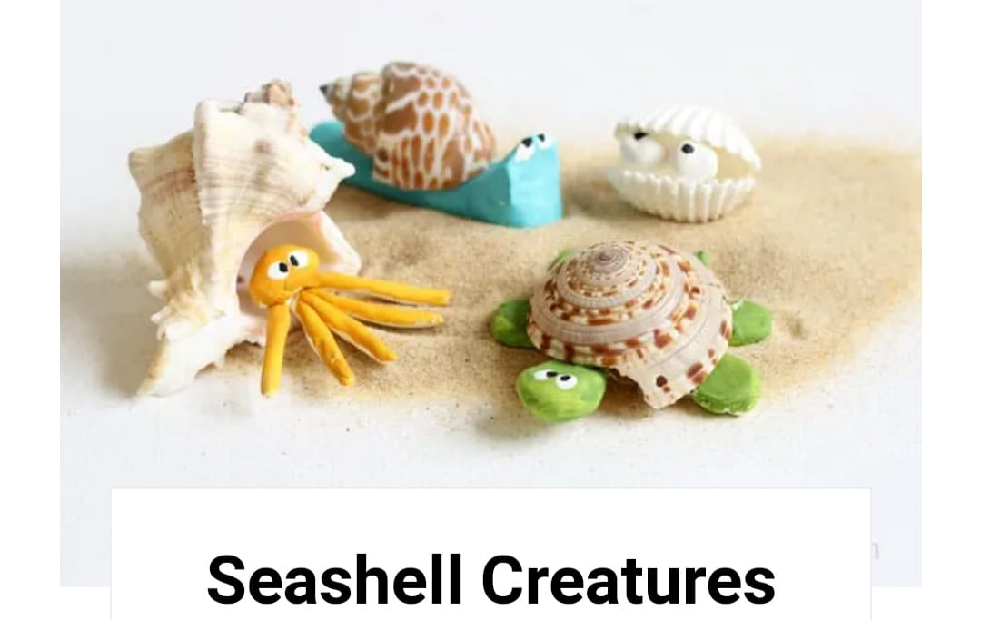

SUBJECT-LIBRARY
