पीएम श्री केंद्रीय विद्यालय जोशीमठ
शीतकालीन गृह कार्य
कक्षा.9
विषय- हिंदी

1 एक औपचारिक पत्र लेखन
2 अलंकार की परिभाषा, प्रकार, उदाहरण।
3 10 पेज सुलेख लेखन
4 उपसर्ग प्रत्यय परिभाषा उदाहरण सहित लिखो

SUBJECT- ENGLISH
1. Learn and revise all the syllabus done till date.
2. Make a diary entry of the most memorable day of your life.
3. Write the poetic devices with example the road not taken, No men are foreign, The lake Isle of Innis free, A legend of the northland.
4. Write two short stories in your English notebook.
5. Read an English newspaper daily. Cut and paste two articles you liked the most and write meanings of the new words you come across. (5 words from each article)
6. Revise the topic tense and write an example of each tense. (3Tenses×4sub-parts=12)
7. Do ten examples related to the topic: Subject Verb Agreement.

SUBJECT- MATHS
- Solve periodic test paper 3
- Complete activities from6-10 in lab activity file
- Complete your portfolio
- Solve the two sample papers given in group

SUBJECT- PHYSICS
- Project on the topic reflection of sound & their applications in daily life.
- Write and revise chapter no.7, 8, 9 &10 exercise in CW notebook and learn (will be asked in oral test).
- Solve 3 CCT questions in CW notebook.
- Make a model on one of the theme.
Theme: - Science & Technology for Society
Subtheme:-
1. Health
2. Life Style for Environment
3. Agriculture
4. Communication & Transport
5. Computational Thinking

SUBJECT- CHEMISTRY
1-Complete your notes of all chapter-matter
2-Make a chart by own choice from NCERT book
3- Revise chapter no.1, 2, 3, and 4
4- Make a science working model in group of three students

SUBJECT- BIOLOGY
- Draw the figures of various types of cells present in human body.
- Draw a mind map to show cell components, cell organelles its discoveries and their functions.
- Draw the nucleus of the cell and write a short note for the following
A) Double layered structure which encloses the nucleus
B) Visible entangled mass of thread like structure
C) A darkly stained round structure inside the nucleus
- Differentiate the following terms
A) Cytoplasm and nucleoplasm
B) Plant cell and animal cell
C) Prokaryotic and eukaryotic cell
- Where do the lipids and proteins constituting the cell membrane get synthesized?
- Draw a neat labelled diagram of mitochondria and label its parts-

SUBJECT- SOCIAL SCIENCE
1- Prepare 20 objective (1 mark) questions each from these six chapters:
French Revolution,
India Size and Location,
What is Democracy, Why Democracy?
Story of Village Palampur
Physical features of India
Constitutional Design
2- Draw and Label map of France from the chapter French Revolution (Page 9 of NCERT History book.)
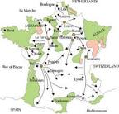
3- Prepare map work from these chapters-
1: India Size and Location:
1) The island groups of India lying in the Arabian Sea and the Bay of Bengal,
2) The countries constituting Indian Subcontinent,
3) The states through which the Tropic of Cancer passes,
4) The strait separating Sri Lanka from India,
5) The place situated on the three seas.
2: Physical features of India: Mountain Ranges:
The Karakoram, The Zaskar, The Patkai Bum, The Jaintia, The Vindhya Range, The Aravali, The Cardamon hills, The Indian desert, The western Ghats. Peaks: K2, Kanchenjunga, Nanga Parbat, Anai Mudi, Maherdragiri.

4- Make a collage on Economic Activities practiced in Rural Areas (Farm & Nonfarm activities)

5- We need to live in harmony with nature. It’s not nature that kills people but its careless and conquering nature -the approach of people that converts the places into concrete jungle that threatens life. This can be visualized through the recent experiences in Joshimath and Mumbai.
Make a project of disaster management any one of the below given topics:
Sinking Joshimath OR Heat waves in Mumbai
1. Support your project with given guidelines: Introduction of the places-Location, Type of disaster, Reasons for disaster, its adverse effects, Mitigation strategies to avert such disasters.

SUBJECT-ARTIFICIAL-INTELLIGENCE
1. What are an A.I Ethics?
2. What is Neural Network? Define the relation between Neural Network & Nervous System in human body.
3. What is data & information? Explain with example.
4. What is an A.I Project Cycle? Explain its all stages.

SUBJECT-ART
Make a 5 Clay craft like Caterpillar, owl, Bug Garden Stakes, medals, sea creatures, mini cupcakes, Bee and flower tic tac toe game, clay fish and many more.
For Examples.
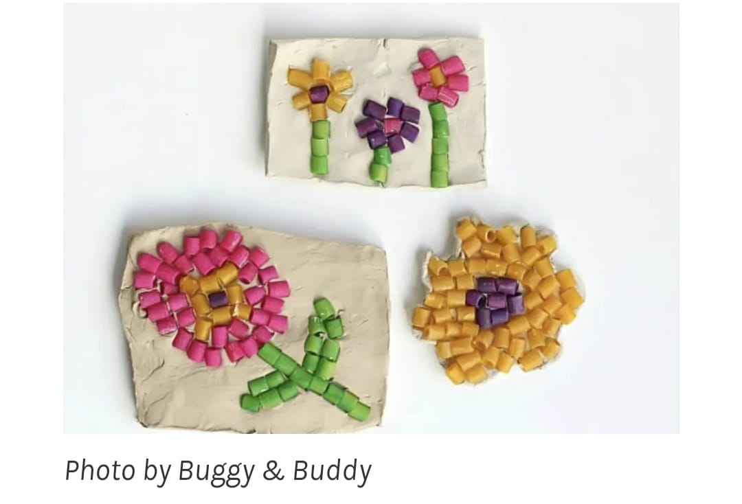

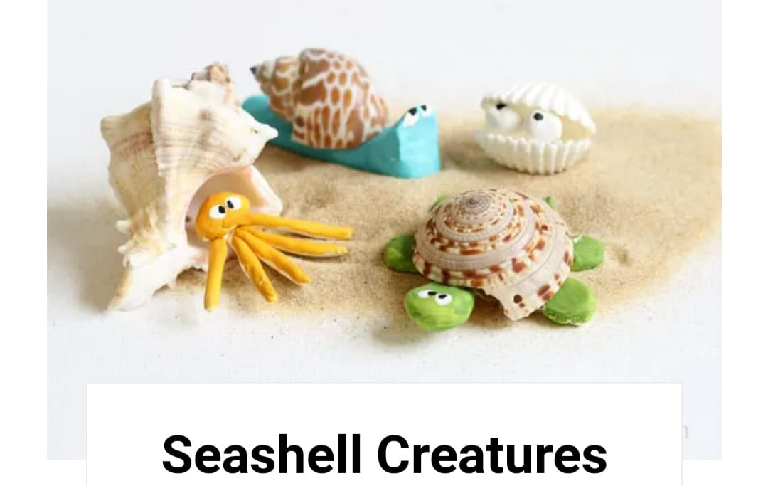
SUBJECT- LIBRARY
Reading newspaper daily and writing the clippings in copy date wise.
Read any book and make book cover page design on sheet.

