पीएम श्री केंद्रीय विद्यालय जोशीमठ
शीतकालीन गृह कार्य
कक्षा.7
विषय- हिंदी
1- भारत के राज्यों के नाम लिखें तथा उन राज्यों के स्थानीय भोजन का नाम लिखकर उसे बनाने की विधि लिखो।
2- अपने प्रिय पर्यटन स्थल के बारे में 100 शब्दों में लिखिए।
3- अपने क्षेत्र में हो रही विद्युत की समस्या के समाधान के लिये विद्युत विभाग के अभियन्ता को पत्र लिखो।
विषय- संस्कृत
1- स्वविद्यालयविषये पंचवाक्यानि संस्कृतभाषायां लिखत।
2- भानु शब्दस्य शब्द रूपाणि लिखत

SUBJECT-ENGLISH
- Write down any 3 poems other than your text book.
- Make a cartoon strip depicting the story of the chapter (any 4 chapters after half yearly exam).
- Write a paragraph on your career goal. Stick or make pictures related to it and create a collage.
- Write a story or a poem on your own which is NOT copied from anywhere.
- Write 5 diary entries.

SUBJECT- MATHS
Note: Do holiday homework in practical file pages (one side ruled and one side blank) and staple them together with index
- Draw all English alphabets from A- Z and write and draw their lines of symmetry
- Learn table from 2-20
- Draw square, rectangle, scalene triangle, isosceles triangle, equilateral triangle, parallelogram,circle,star,tree,flower and draw and write their lines of symmetry
- Do the given questions
-Ex 8.1 Q1 (iii) 3(i), 4(ii) 7(ii) 10(iii)
-Ex 8.2 Q 1(I, vii), 2(ii, iv) 3(ii, vi) 4(v, vii)
-Ex 9.1Q 2, 7
- Ex 9.2 Q 3, 10,12,14,16
-Ex 10.1Q 1, 4(b), 5
-Ex 10.2 Q 6
-Ex 11.1Q 5, 6, 7
-Ex 11.2 Q 2, 5

SUBJECT- SCIENCE
- Project on the topic how to manage waste water in your locality.
- Write and revise chapter no.7, 8, 9 &10 exercise in CW notebook and learn (will be asked in oral test).
- Solve 5 CCT questions in CW notebook.
- Make a model on one of the theme.
Theme: - Science & Technology for Society
Subtheme:-
1. Health
2. Life Style for Environment
3. Agriculture
4. Communication & Transport
5. Computational Thinking

SUBJECT- SOCIAL SCIENCE
1. Case study of Ahom’s tribe describing their:
Customs
Culture
Food Habits
Location

2. Map Pointing
Plot the location of various tribes like Bhils, Gond, Santhals, Banjaras.
Make it more interesting by pasting pictures of these tribes.

3. Collage Making
Collect pictures of Chaitanya, Mirabai, Kabir, Surdas, Tulsidas, Guru Nanak. Prepare a collage on A3 size sheets, and also write their contribution in the society. Make it more interesting by pasting colourful pictures.

4. Collage Making
Students will make collage on an A4 size sheet.
They will collect information about some of important women who provided their contribution in socio- economic development. Present their picture along with contribution.

5. Case Study: The River Ganga
In what ways has industrialization in India affected the Ganges River?
How does water pollution affect the health and daily lives of people, aquatic lives etc.
GAP (Ganga Action Plan) by 2010.
Mark/Locate river Ganga on India Political map.

SUBJECT-ART
Make a 5 Clay craft like Caterpillar, owl, Bug Garden Stakes, medals, sea creatures, mini cupcakes, Bee and flower tic tac toe game, clay fish and many more.
For Examples.
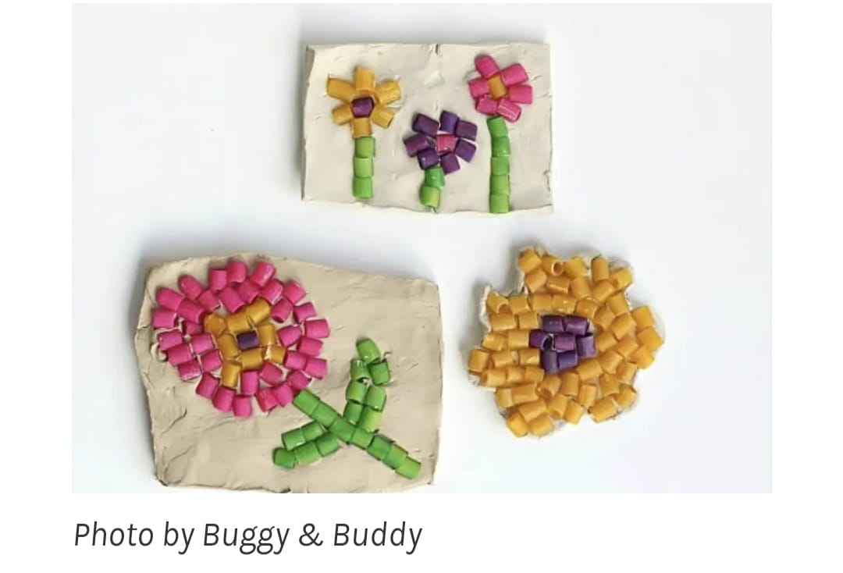

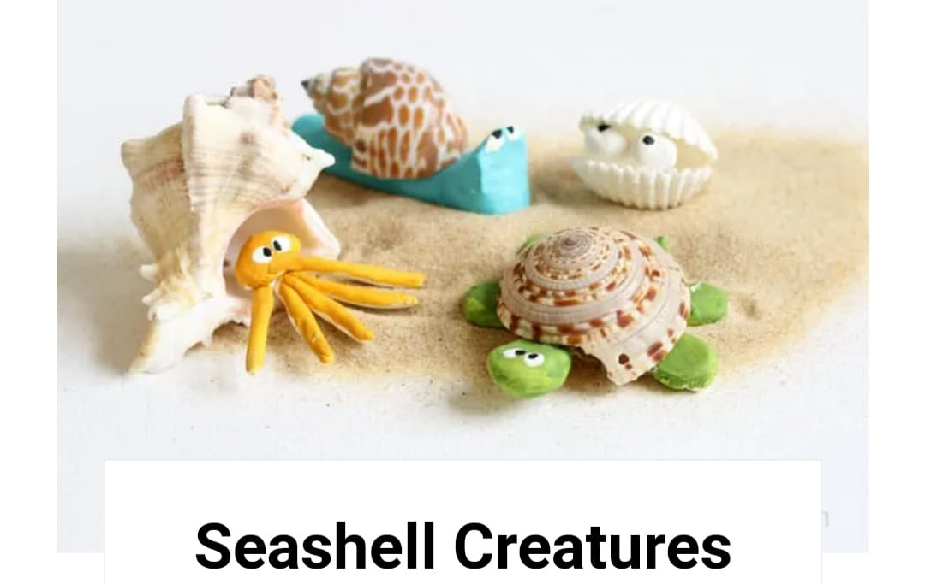
SUBJECT-LIBRARY
Read any books two books one in Hindi and one English. Write book review on designer sheet and prepare book cover page also. Making different types of book marks by checking videos online.

