पीएम श्री केंद्रीय विद्यालय जोशीमठ
शीतकालीन गृह कार्य
कक्षा.8
विषय- हिंदी
1-अपने क्षेत्र में हो रही पेय जल की समस्या के समाधान के लिये जल निगम के कनिष्ठ अभियन्ता को पत्र लिखो।
2-वार्षिक परीक्षा की तैयारी करने के लिये अपने छोटे भाई को पत्र लिखो।
3- पानी की कहानी पाठ के आधार पर नदी की कहानी लिखो।
विषय- संस्कृत
1-मातृ शब्दस्य शब्दरूपाणि लिखत।
2- खाद धातुरूपाणि लिखत।

SUBJECT-ENGLISH
Learn and revise all the syllabus done till date.
2. Letter writing _ write two letters to the Editor
3. Make a diary entry of the most memorable day of your life.
4. Revise the topic tense and write an example of each tenses. (3 tenses ×4 sub parts=12
5 solve four unseen passage and paste it in your notebook.

SUBJECT-MATHS
Note: Do holiday homework in practical file pages (one side ruled and one side blank) and staple them together with index)
- Learn table from 2-20
- Solve question paper of periodic test 2
- Collect data of cost of any fruit and quantity in kg and draw it's graph
- Collect data of any 5 consecutive days of minimum and maximum temperature of your city and draw it's line graph
- Do the given questions
-Ex 8.1 Q 2
-Ex 8.3Q 4
-Ex 8.4Q 3
-Ex 9.1 Q 2,5,7
-Ex 9.2 Q 3,8,9
-Ex 9.3 Q 3,4,8
-Ex 10.1 Q 3,4,5,7
-Ex 10.2 Q1
-Ex 11.1 Q 4,8,10
-Ex 11.2 Q 2,8,10
-Ex 12.2 Q3(i,iii,viii),4(i,ii)5
-Ex 12.Q5

SUBJECT-SCIENCE
1-Complete your note book (notes and NCERT exercise)
2-Make a chart of topic which assign in class
3- Revise chapter no.1, to 13 all
SUBJECT-SOCIAL SCIENCE
1. Interview
Interview your grandparents on the education pattern during their times and prepare a comparative analysis of both the education systems.

2. Census Comparison
Collecting data on last two census of India, Analyse data and compare the growth of population in India with the world.

3. Survey on Women's Liberation
Interview women of different generations e.g. your grandmother, mother, sister, friend and discuss the Hardships women have been facing from decades. List some revolts lead by the women in history.

4. Imagine yourself as a freedom fighter. Which method of protest would you use? Violence or Non-violence? Justify.

5. Collect news paper articles on challenges that are still there right from Independence of India. How do you think that these can be resolved?

6. Find out the number of high courts in India write down the names / places where they are existing. And locate on map also.

7. Compare the agriculture of USA with agriculture in India. Collecting information on their size of land holdings, investments, production and Govt. policies etc. Suggest some ways to improve condition of agriculture in India.

8. Map
On an outline map of India and world, locate major industrial regions. Use appropriate symbols for them.

SUBJECT-ART
Make a 5 Clay craft like Caterpillar, owl, Bug Garden Stakes, medals, sea creatures, mini cupcakes, Bee and flower tic tac toe game, clay fish and many more.
For Examples.
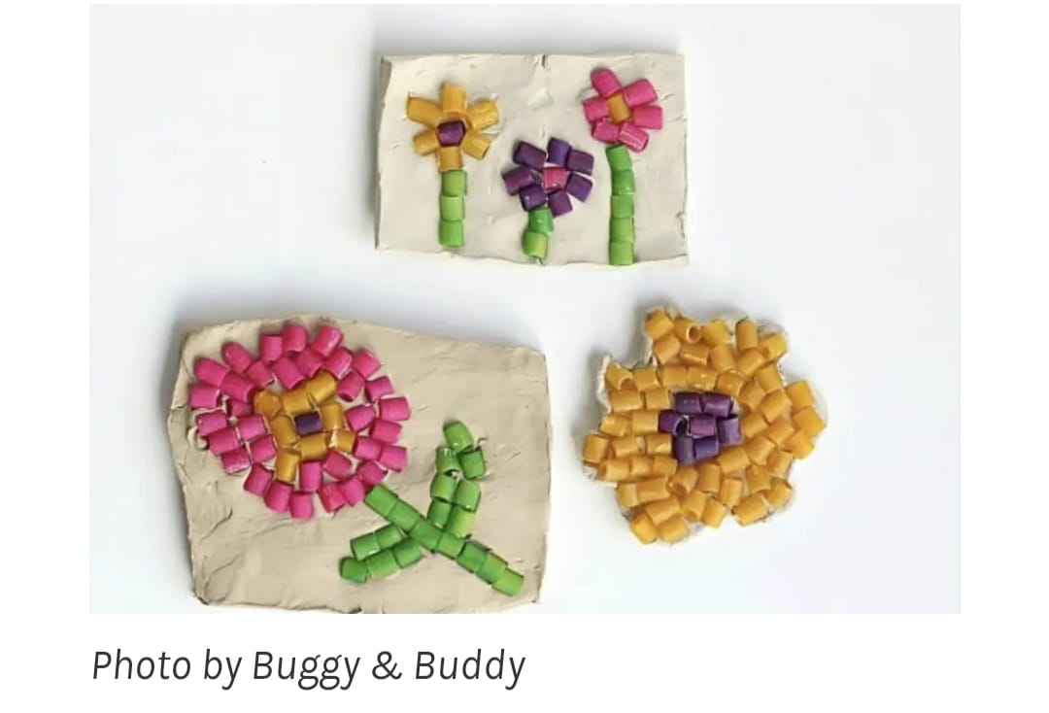

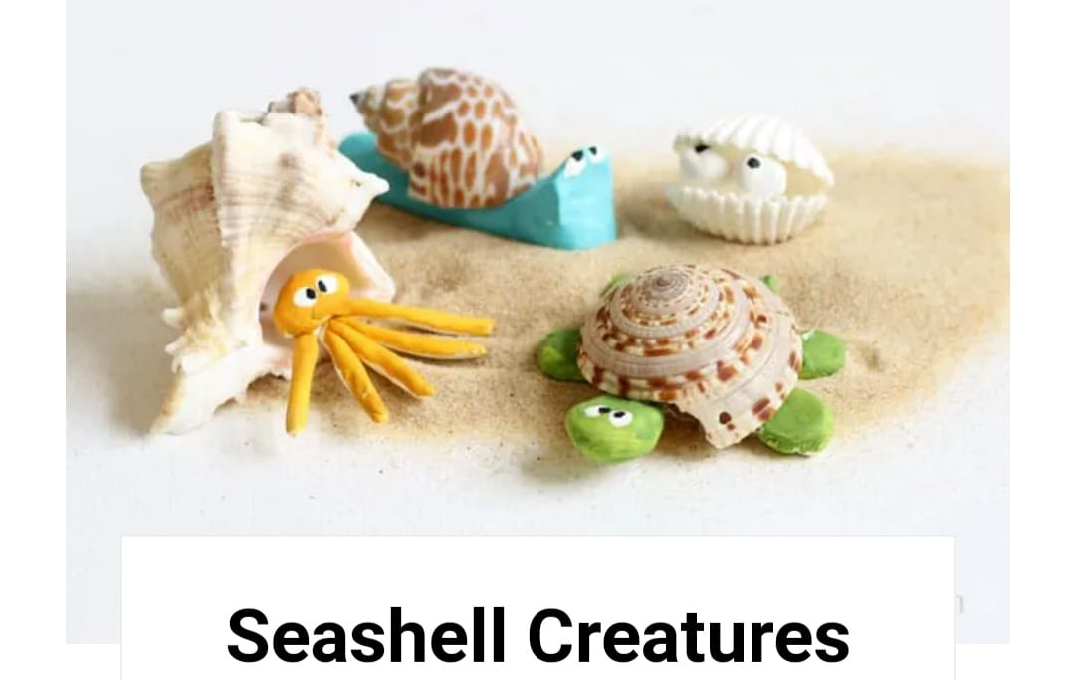
SUBJECT-LIBRARY
Read any books two books one in Hindi and one English. Write book review on designer sheet and prepare book cover page also. Making different types of book marks by checking videos online.

