पीएम श्री केंद्रीय विद्यालय जोशीमठ
शीतकालीन गृह कार्य
कक्षा.10
विषय- हिंदी
1 सैंपल पेपर हल करना है
2 माता का अंचल, साना साना हाथ जोड़ी पाठ से 3 प्रश्नोत्तर लिखना है
3 वाक्य भेद , वाच्य परिभाषा, प्रकार, उदाहरण
4 पद परिचय उदाहरण सहित लिखो

SUBJECT- ENGLISH
1. Learn and revise all the syllabus for the preparation of Board exam.
2. Solve four CBSE Sample Papers for your better practice.
3. Letter writing – Write two letters of order placement and letter to Editor.
4. Write two analytical paragraphs.
5. Write the poetic devices with example and explanation used in the poem: Dust of snow, Amanda, How to tell wild animals and The tale of Custard the dragon.
6. Read an English newspaper daily. Cut and paste two articles you liked the most and write meanings of the new words you came across. (5 words from each article) 7. Revise the grammar topics (Tenses, Modals, Subject Verb Agreement) and do exercise of each topic.

SUBJECT- MATHS
- Solve the pre board 1 and pre board 2 question paper
- Do and revise all the work done in remedial classes
- Solve two sample papers given
- Complete lab activities from6-10 in lab activity file
- Complete your portfolio

SUBJECT- PHYSICS
- Solve 10 Sample Paper in your notebook
- Solve case study based questions in CW notebook.
- Prepare a mind map, flow chart for each chapter.
- Solve NCERT examples, exercise & Exemplar questions in your notebook
- Make a model on one of the theme.
Theme: - Science & Technology for Society
Subtheme:-
1. Health
2. Life Style for Environment
3. Agriculture
4. Communication & Transport
5. Computational Thinking

SUBJECT- CHEMISTRY
1--Complete your notes and NCERT exercise in note book
2-Revise chapter-1, 2 3, 4
3- Make chart of any topic from NCERT book

SUBJECT- BIOLOGY
Solve cbse sample paper

SST WINTER HOLIDAY HOMEWORK 2023-24

ECONOMICS
Write notes on following
i) All about the Money and credit
ii) Modern forms of money.
iii) Formal & Informal sector credit in india
iv)Self help group for poor
v) Globalisation and its impact in india
vi) Factors that have enabled Globalisation
vii) Interlinking production across countries
GEOGRAPHY
Write notes on following
i) Importance of manufacturing.
ii) Classification of industries
iii) MAP WORK: - Iron and steel plants, Software technology parks

HISTORY
Write notes on following
i) The Non cooperation movement & Civil Disobedience Movement.
ii) 10 Freedom Fighters and their roles in Indian Freedom Struggle.

Map work :
a)Important centres of the freedom movement in India from 1857 to 1947.
b) Important Sessions of Indian National Congress from 1885 to 1947.

Political Science
i) What are the functions of a political party?
ii) What suggestions are given to reform political parties?
iii)How does democracy provide a more accountable, responsive and legitimate Government?
iv) “Democracy has failed to reduce inequality and poverty” Examine.

Note : Answers of the above questions are to be written in your fare notebook .

SUBJECT-ARTIFICIAL-INTELLEGENCE
1. Write a program to input two numbers and swap them.
2. Write a program to accept the year and check if it is a leap year or not.
3. What is the differences between Human Language vs Computer Language?
4. What is the concept of Natural Language Processing?
5. Explain Text-processing, Data-processing, and Bag of words.

SUBJECT-ART
Make a 5 Clay craft like Caterpillar, owl, Bug Garden Stakes, medals, sea creatures, mini cupcakes, Bee and flower tic tac toe game, clay fish and many more.
For Examples.
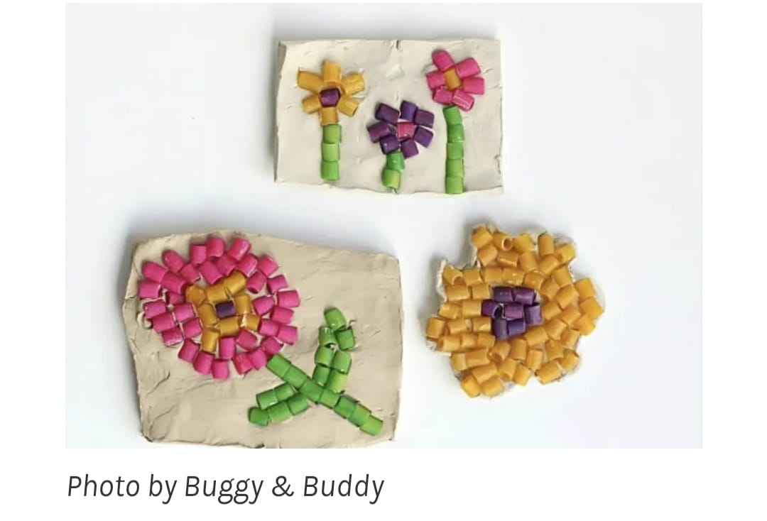

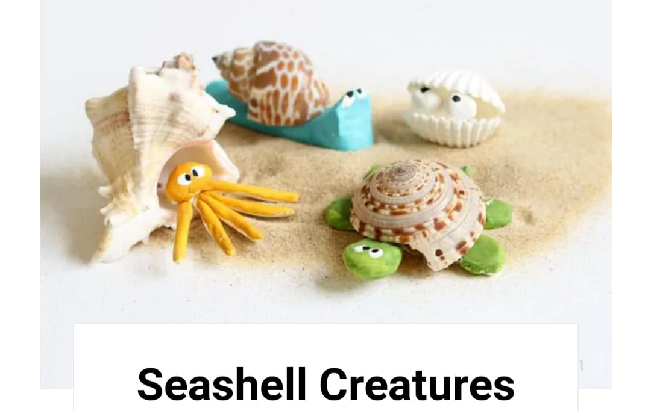

SUBJECT- LIBRARY
Reading newspaper daily and writing the clippings in copy date wise.
Read any book and make book cover page design on sheet.

