पीएम श्री केंद्रीय विद्यालय जोशीमठ
शीतकालीन गृह कार्य
कक्षा.6
विषय- हिंदी
1- विद्यालय में हिन्दी व्याकरण की पुस्तकें मँगवाने के लिये अपने प्राचार्य को प्रार्थना-पत्र लिखो।
2-भारत के मानचित्र में प्रत्येक राज्य के लोकनृत्य के नाम दर्शाइये।
विषय- संस्कृत
1-लिख धातु रूपाणि लिखत।
2- बालिका शब्दस्य रूपाणि लिखत।
3- संस्कृते 1त: 50 पर्यन्तं संख्या: लिखत।

SUBJECT-ENGLISH
1 Solve any two unseen passage and paste it in your notebook.
2 Learn and revise all the syllabus done till date.
3 Write any two notices of found and lost.
4 Write a letter to the principal of your school asking for the leave for one week for your cousin's marriage.
5 Learn and write 25 word meanings from your textbook.

SUBJECT-MATHS
Note: Do holiday homework in practical file pages (one side ruled and one side blank) and staple them together with index
- Draw any 5 objects around you that have line of symmetry and draw their line of symmetry
- Draw all English alphabets from A- Z and write and draw their lines of symmetry
- Learn table from 2-20
- Do the given questions
-Ex 8.2 Q no 1, 4
-Ex 8.3 Q no 4, 7
-Ex 9.1 Q no 1,3,4,6
-Ex 10.1 Q no 6, 9, 14, 15
-Ex 10.3 Q no 8, 9, 11, 12
-Ex 11.1 Q no 1,7,10
-Ex 12.1Q no 7,10,14,15
-Ex 12.2 Q no 4
-Ex 12.3 Q no 2, 6,8,11

SUBJECT-SCIENCE
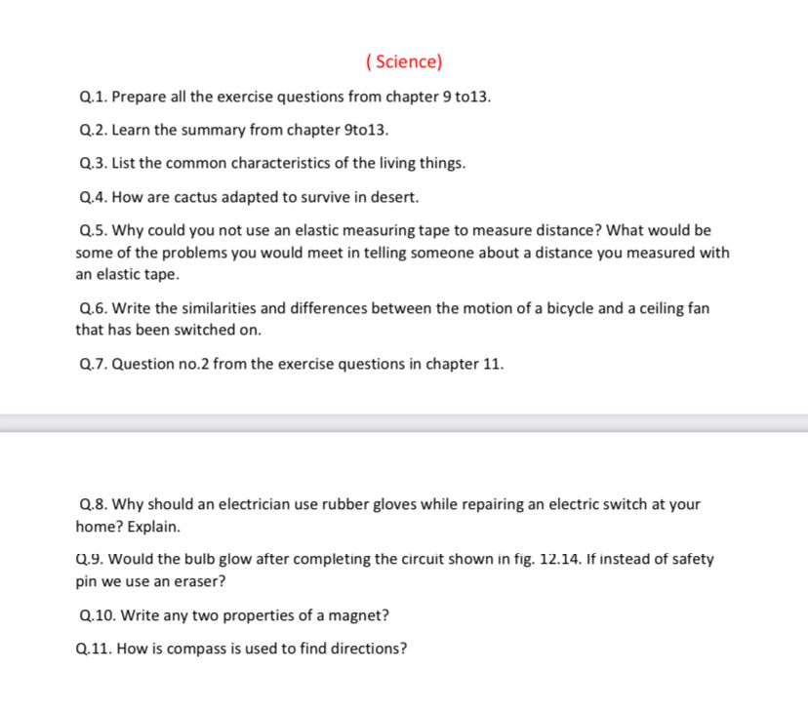

SUBJECT-SOCIAL SCIENCE
1. There are several pilgrimages that are performed by people of India. Find out about any one of them and write a short paragraph about it.

2. Mahatma Gandhi strongly believed that all adults in Indian should be given the right to vote. Many people thought that illiterate and poor people should not be given the right to vote.
(A) What do you think on this issue?
(B) Write down your view in your notebooks.

3. List the different occupations that the people of the villages or self employed in towns take up and point out the difficulties faced by them.

4. Draw a plan of your school and show the following-
(a) Your classroom
(b) Playground
(c) Staff room
(d) Principal room
(e) Assembly Ground
(f) Library
Note: Drawing to be done on A4 sized sheets and paste in notebook.

5. India is famous for its tourism. Find out at least 10 tourist places of India and name the states in which they are found. Locate and label the states on the political map of India.
Note: Information and map work to be done in the notebooks.

6. Map-
- Major continents
- Major oceans
- India’s Neighbouring country

SUBJECT-ART
Make a 5 Clay craft like Caterpillar, owl, Bug Garden Stakes, medals, sea creatures, mini cupcakes, Bee and flower tic tac toe game, clay fish and many more.
For Examples.
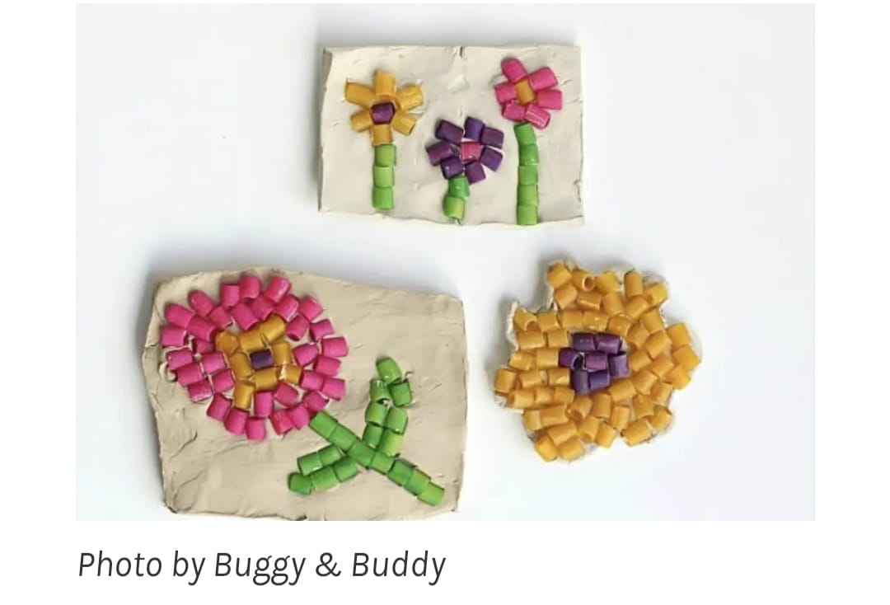

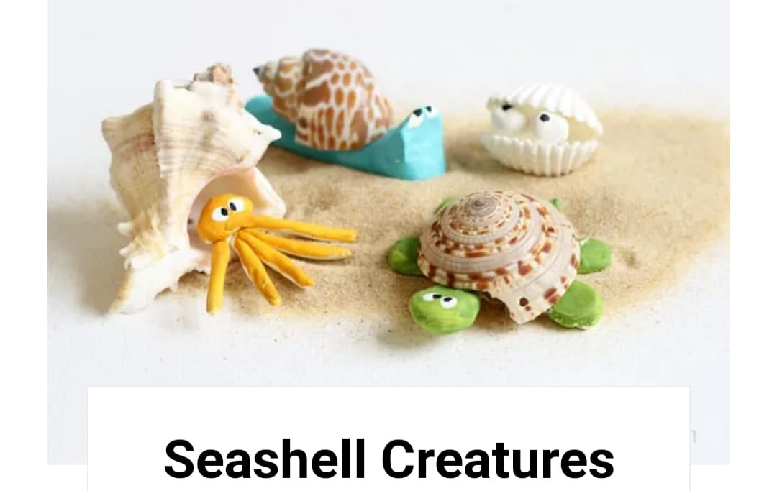

SUBJECT-LIBRARY
Read any books two books one in Hindi and one English. Write book review on designer sheet and prepare book cover page also. Making different types of book marks by checking videos online.

